|  |
| --- |
|  |
| Specification Document |
| StackOverflow-Like |
|  |
| **Damien MOREL and Maxime MIKOTAJEWSKI** |
| **2/16/2016** |

|  |
| --- |
|  |

# UML Analysis

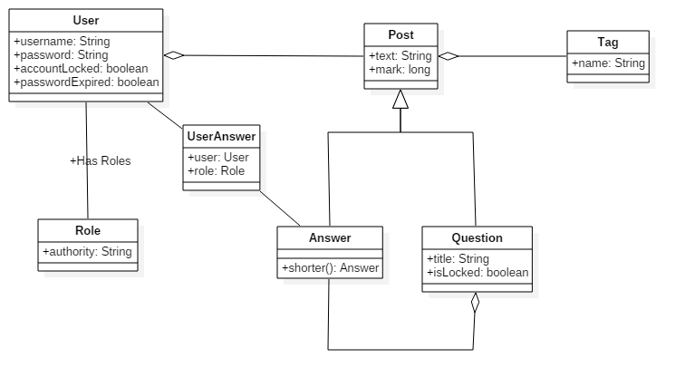

Figure 1 : Class Diagram of the application

# Functional specifications

Here, we will list all the features included in our application.

## Basic features :

* Anybody can register as a user, and directly log on his account.
* Anybody can view questions displayed on home
* Users can post questions
* User can answer to questions
* Every user has a page where you can see the number of posts he submitted, and his latest posts.
* The application includes a search feature by tags, and by words.

**Question features :**

* Users who asked a question can edit it in order to add details or remove a typo
* Users can access to an user profile from the question page
* Users can answer to a question
* Questions have titles.
* Users can add tags to their questions, in order to make them easily findable by other users, when they use the “Search By tag” feature.

**Answer features:**

* An user can edit his answer.
* Users can upvote or downvote answers, in order to make them more visible to the community
* Users can cancel or change their votes whenever they want
* Answers are sorted by their score

**Admin features:**

* Administrators can lock a topic when they think the question is solved, or if answers are not relevant anymore, and unlock it afterwards, thanks to a button located on the page of every question.
* Admins can access to the Spring Security UI features in order to manage users’ accounts, promote users to the role of administrator, lock accounts and modify a lot of things.

# UI Mockups

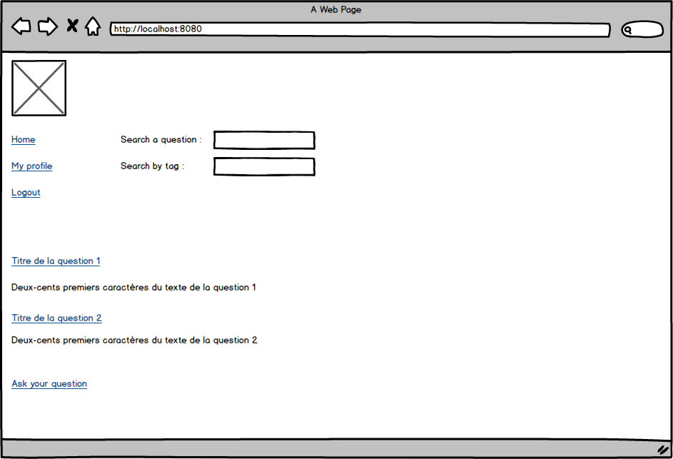

Figure 2 : Homepage without being logged in

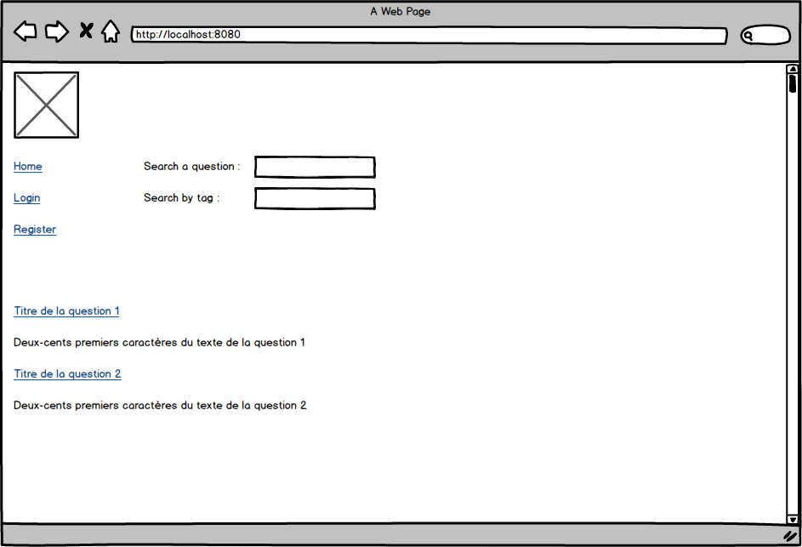

Figure 3 : Homepage while being logged in

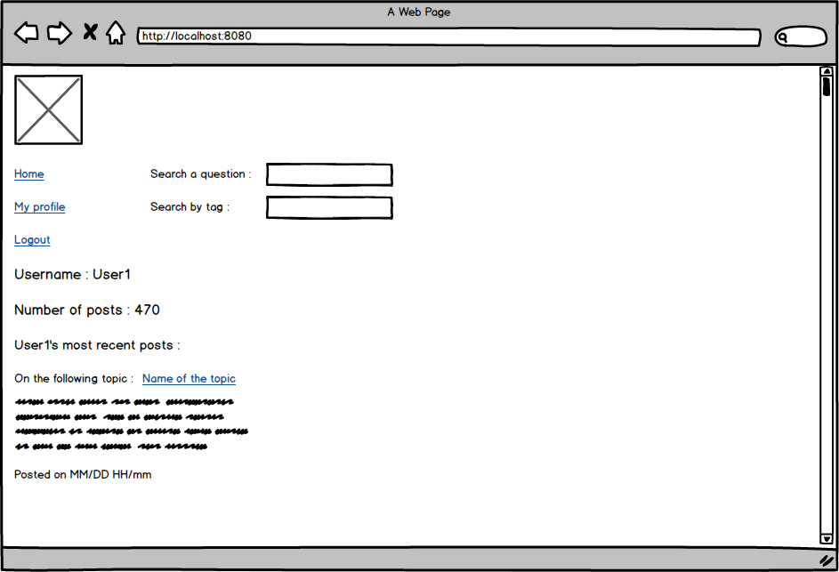

Figure : User page

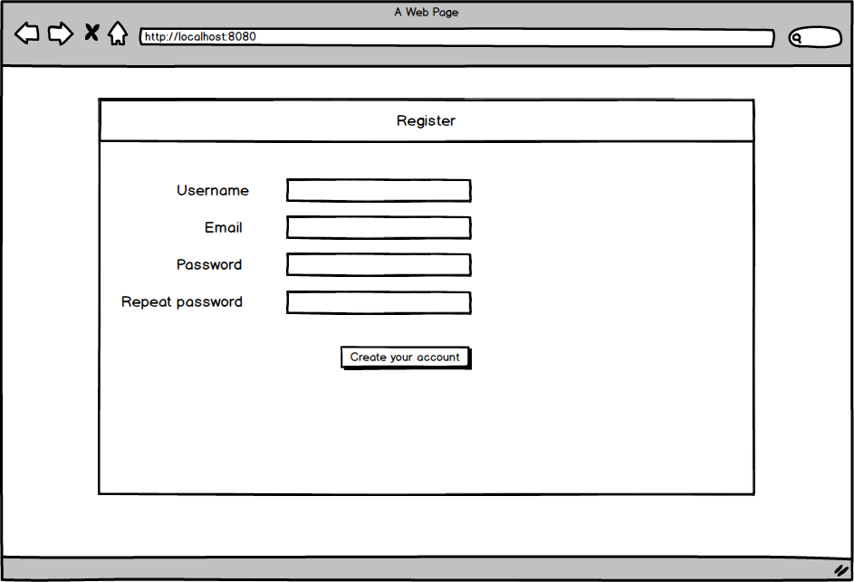

Figure : Register screen

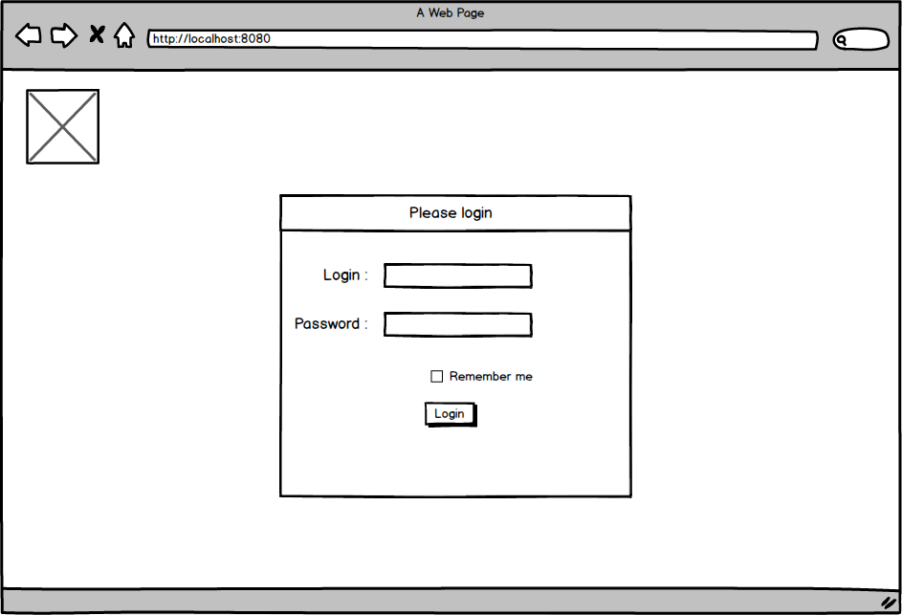

Figure : Login screen

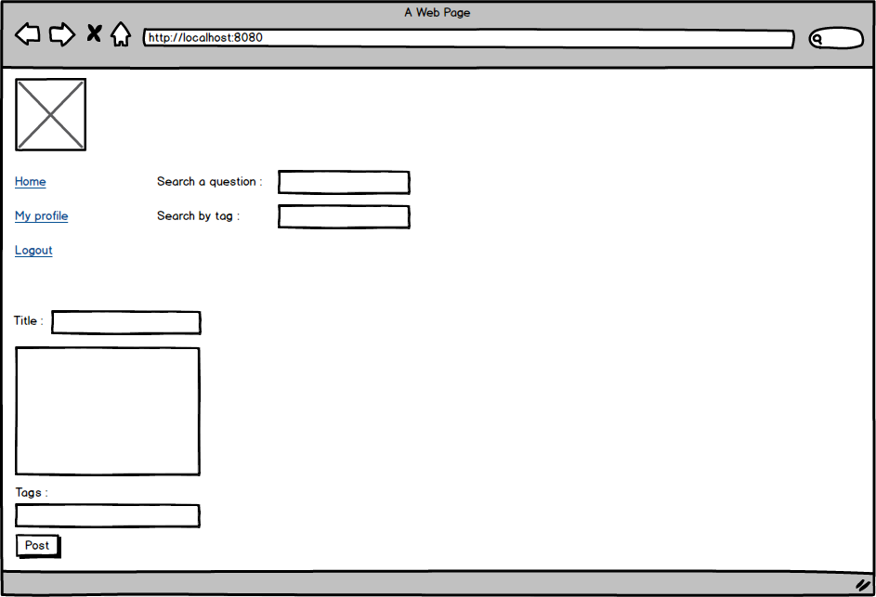

Figure : Post a question screen

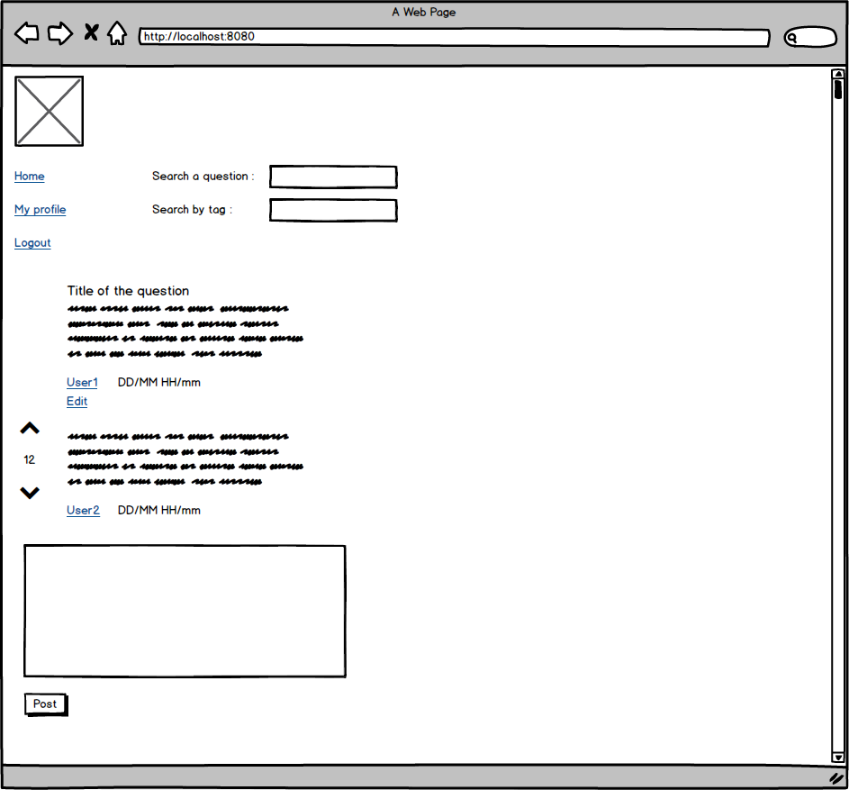

Figure : Question page

# Additional informations

In order to make the application more easily testable when we launch it, we created two users by default, one called « me » (password : password), which is an admin account, and user (password : user) which is a regular user.

We also created a few questions with answers, to test features like displaying and editing.